**RESUME**

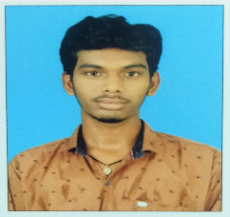

**BHOGIREDDY.PADMA SAI**

**S/o VENKATA SATYANARAYANA**

**D.No 1\55, Mahatma Gandhi Street,**

**Pippara , Ganapavaram Mandal,**

**West Godavari Dist, Mobile : +91 9666793126**

**ANDHRAPRADESH – 534197 Email id :** [**padmasai696469@gmail.com**](mailto:padmasai696469@gmail.com)

**Career Objective:**

To be associated with affirm, that provides career development opportunities and to contribute in its progress through my knowledge and skills.

**Educational Qualification:**

|  |  |  |  |
| --- | --- | --- | --- |
| **Course** | **Institution** | **Year of Passing** | **Grade** |
| Intermediate (M.P.C) | Aditya Junior College, Tadepalli Gudem | 2019 | 9.79 |
| SSC | Sri Chaitanya Techno School, Tadepalli Gudem | 2017 | 9.2 |

**Technical Skills :**

* Java

**Strength:**

* Adaptability
* Self Motivate
* Hard Working

**Hobbies activities:**

* Listening to music
* Reading Books
* Playing Cricket

**Personal Details:**

Name : Bhogireddy. Padma sai

Father’s Name : B.Venkata Satyanarayana

Date of Birth : 16- May-2001

Gender : Male

Marital Status : Single

Languages Known : English, Telugu

Nationality : Indian

Religion : Hindu

**Declaration:**

I hereby declare that the information furnished above is true to the best of my knowledge.

Date:20-12-2020

Place: Pippara

Signature

(B.Padma sai)

